Query the names of all the Japanese cities in the **CITY** table. The **COUNTRYCODE** for Japan is JPN.  
The **CITY** table is described as follows:  
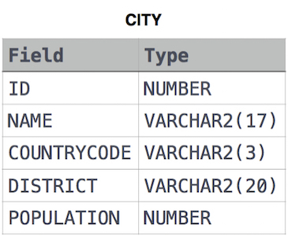

Ans:

Select NAME from CITY where COUNTRYCODE='JPN';